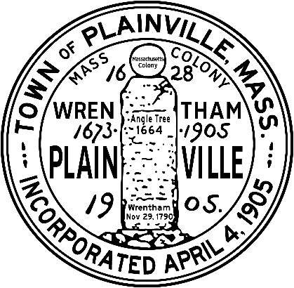
THE COMMONWEALTH OF MASSACHUSETTS
TOWN OF PLAINVILLE
OFFICE OF LICENSING BOARD
COMMON VICTUALLER
NEW APPLICATION CHECKLIST

- Completed Application for Common Victualler License filed with the Town Administrator Office, 190 South Street, Plainville, MA 02762.
(Please visit the Board of Health and Building Department for requirements prior to submitting the application to the Select Board.)

- Submit a copy of the Health Inspection Report and Board of Health Permit with application.

- Copy of the blueprints or a hand drawn diagram (drawn to scale) of the premises. If leased provide a copy of the lease agreement.

- Workers’ Compensation Certificate of Insurance per M.G.L., Chapter 152, Section 25A. Contact your insurance company and have them fax to the attention of the Select Board @ 508-695-1857. Please list the Town of Plainville as “Certificate Holder”.

- State Workers’ Compensation Insurance Affidavit – Even if your establishment does not require Workers’ Compensation this must be filled out.

- Fire Inspection Report – Per Fire Code Compliance Policy for Businesses and All License Holders approved by the Select Board. Call the Fire Department @ 508-695-5252.

- Business Certificate per MGL Chapter 110, Section 5 & 6; any person conducting business in the Commonwealth under any title other than the real name of the person conducting the business, whether individually or as a partnership, or under the true corporate name. See Town Clerk.

- Emergency Contact Information to include: Contact name and phone number, hours of operation and whether the premises are alarmed.

- Check made out to the Town of Plainville for the new license request in the amount of $25

