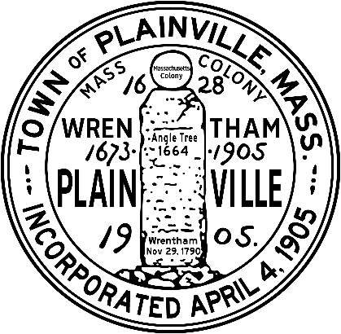
THE COMMONWEALTH OF MASSACHUSETTS
TOWN OF PLAINVILLE
OFFICE OF LICENSING BOARD
AUTOMATIC AMUSEMENT
NEW APPLICATION CHECKLIST

- Completed Application for Automatic Amusement Device License filed with the Town Administrator Office, 190 South Street, Plainville, MA 02762.

- Articles of Organization (if a corporation) as filed with the Massachusetts Secretary of State. Must contain the Seal of Secretary of State.

- Copy of the blueprints or a hand drawn diagram (drawn to scale) of the premises. If leased provide a copy of the lease agreement.

- Workers’ Compensation Certificate of Insurance per M.G.L., Chapter 152, Section 25A. Contact your insurance company and have them fax to the attention of the Select Board @ 508-695-1857. Please list the Town of Plainville as “Certificate Holder”.

- State Workers’ Compensation Insurance Affidavit – Even if your establishment does not require Workers’ Compensation this must be filled out.

- Fire Inspection Report – Per Fire Code Compliance Policy for Businesses and All License Holders approved by the Select Board. Call the Fire Department @ 508-695-5252.

- Business Certificate per MGL Chapter 110, Section 5 & 6; any person conducting business in the Commonwealth under any title other than the real name of the person conducting the business, whether individually or as a partnership, or under the true corporate name. See Town Clerk.

- Emergency Contact Information to include: Contact name and phone number, hours of operation and whether the premises are alarmed.

- Check made out to the Town of Plainville for the following new license request:

Automatic Amusement - $20/per machine – maximum $200

Return Checklist and Application to the Select Board’s Office.
THE COMMONWEALTH OF MASSACHUSETTS
TOWN OF PLAINVILLE
OFFICE OF LICENSING BOARD
AUTOMATIC AMUSEMENT APPLICATION

To the Town of Plainville Local Licensing Authority:

The undersigned hereby applies for a License in accordance with the provisions of the Statues relating therto. The application must be completed with full details.

Name of Applicant: ____________________________________________

Business Name: ____________________________________________

Business Address: ____________________________________________

Phone Number: ____________________________________________

Please list Name and Type of each Coin Operated Device Separately:
Note: Pool Tables are Licensed under a Pool Table License.

Device Name: _________________ Device Name: __________________

Device Name: _________________ Device Name: __________________

Device Name: _________________ Device Name: __________________

Device Name: _________________ Device Name: __________________

Device Name: _________________ Device Name: __________________

I certify under the penalties of perjury that I, to my best knowledge and belief, have filed all state tax return and paid all state taxes required under law.

_____________________________ _________________
Signature Date

___________________________
Title

