Monday afternoon cribbage

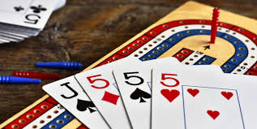

Cribbage every Monday 12:30-3:00 at the Plainville Senior Center (upper Level)

