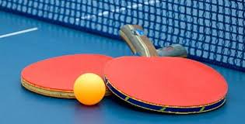

Join us every Tuesday 12:00-2:00 in the lower level of the Plainville Senior Center

Benefits of playing table tennis

- Increase activity in the brain after only 10 minutes
- Increases your heart rate while playing for overall health
- Improves your eye hand coordination
- A great way to exercise with friends
- Burns calories
- Easy on the joints


